**JANUARY—“ Lion King” Rehearsal Schedule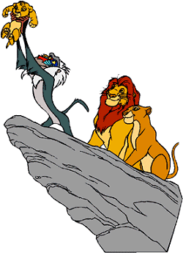**



|  |  |  |  |  |  |  |
| --- | --- | --- | --- | --- | --- | --- |
| **Sun.** | **Monday** | **Tuesday** | **Wednesday** | **Thursday** | **Friday** | **Sat.** |
| 5 | 6 | 7 | 8 | 9 | 10 | 11 |
|  | **3:45-5:30 p.m.: Circle of Life Pronunciation:** Required for Everyone | **Music Rehearsal: 3:45-5:30 p.m.:** Required for Everyone | **Music Rehearsal: 3:45-5:30 p.m.:** Required for Everyone | **Music Rehearsal: 3:45-5:30 p.m.:** Required for Everyone in the Ensemble, Timon, Pumbaa, Simba, and Young Simba | **Choreography Rehearsal: 2:00-3:00 p.m.:** Required for Rafiki, elephants, and monkeys **3:00-4:00 p.m.:** Required for all gazelle and zebras **4:00-5:00 p.m.:** Required for all flamingos and giraffes |  |
| 12 | 13 | 14 | 15 | 16 | 17 | 18 |
|  | **3:45-5:30 p.m.:**  **Grasslands Chant Pronunciation:** Required for everyone in the Ensemble | **Music Rehearsal: 3:45-5:30 p.m.:** Required for everyone in the Ensemble | **Music Rehearsal: 3:45-5:30 p.m.:** Required for everyone in the Ensemble, Timon, Simba, and Nala | **3:45-5:30 p.m.:**  **They Live In You Pronunciation:** Required for Everyone in the Ensemble and Mufasa | **Music Rehearsal: 1:10-3:00 p.m.:** Required for everyone in the Ensemble and Mufasa **Choreography Rehearsal:**  **3:00-4:30 p.m.** Required for Timon, Pumbaa, Simba, and Young Simba |  |
| 19 | 20 | 21 | 22 | 23 | **24** | 25 |
|  | **MLK DAY** | **NO SCHOOL OR REHEARSAL** | **Choreography Rehearsal:**  **3:45-4:45 p.m.:** Required for Simba and Nala | **Choreography Rehearsal: 3:45-5:00:** Required for Lionesses and Mufasa | **Music Rehearsal: 1:10-3:00 p.m.:** Required for Scar and All Hyenas  **Choreography Rehearsal:**  **3:00-4:30 p.m.** Required for Lionesses and Mufasa |  |
| 26 | 27 | 28 | 29 | 30 | 31 | 1 |
|  | **Music Rehearsal:**  **3:45-5:30 p.m.:** Required for Scar and All Hyenas | **3:45-4:45 p.m.:**  **Lioness Hunt Pronunciation:** Required for All Lionesses | **Music Rehearsal:**  **3:45-5:30 p.m.:** Required for All Lionesses | **Choreography Rehearsal 3:45-5:00 p.m.:** Required for Scar and All Hyenas | **Choreography**  **Rehearsal: 2:00-3:30 p.m.:**  Required for Scar and All Hyenas |  |
|  |  |  |  |  |  |  |

 **FEBRUARY—“ Lion King” Rehearsal Schedule**

|  |  |  |  |  |  |  |
| --- | --- | --- | --- | --- | --- | --- |
| **Sun.** | **Monday** | **Tuesday** | **Wednesday** | **Thursday** | **Friday** | **Sat.** |
| 2 | 3 | 4 | 5 | 6 | 7 | 8 |
|  | **Music Rehearsal: 3:45-5:30 p.m.:** Required for Sarabi, Nala, Rafiki, and All the Lionesses | **Music Rehearsal: 3:45-5:30 p.m.:** Required for Sarabi, Nala, Rafiki, and All the Lionesses | **Music Rehearsal: 3:45-5:30 p.m.:** Required for Everyone in the Ensemble, Young Simba, Young Nala, and Zazu | **Choreography Rehearsal 3:45-5:00 p.m.:** Required for Sarabi, Nala, Rafiki, and All the Lionesses | **NO SCHOOL AND NO REHEARSAL** ­­ |  |
| 9 | 10 | 11 | 12 | 13 | 14 | 15 |
|  | **Music Rehearsal: 3:45-5:30 p.m.:** Required for Everyone in the Ensemble, Young Simba, Young Nala, and Zazu | **Choreography Rehearsal 3:45-5:00 p.m.:** Required for All Lionesses and Prideland Animals | **Music Rehearsal: 3:45-5:30 p.m.:** Required for Everyone in the Ensemble and Rafiki | **Choreography Rehearsal 3:45-5:00 p.m.:** Required for All Lionesses and Prideland Animals | **Choreography**  **Rehearsal: 2:00-3:30 p.m.:**  Required for All Prideland Animals, Young Simba, Young Nala, and Zazu |  |
| 16 | 17 | 18 | 19 | 20 | 21 | 22 |
|  | **PRESIDENTS’ DAY NO SCHOOL AND NO REHEARSAL** | **Choreography**  **Rehearsal: 2:00-3:30 p.m.:**  Required for All Prideland Animals, Young Simba, Young Nala, and Zazu | **3:45-5:30 p.m.:**  **Stampede/Mourning Pronunciation:** Required for Everyone in the Ensemble, Sarabi, Nala, Rafiki, and All the Lionesses | **Music Rehearsal: 1:10-3:00 p.m.:** Required for Everyone in the Ensemble, Sarabi, Nala, Rafiki, and All the Lionesses | **NO SCHOOL AND NO REHEARSAL** |  |
| 23 | 24 | 25 | 26 | 27 | 28 | 1 |
| maurice_belle | **Choreography Rehearsal 3:45-5:00 p.m.:** Required for All Lionesses and Rafiki | **Choreography Rehearsal 3:45-5:00 p.m.:** Required for All Lionesses and Rafiki | **Music Rehearsal: 3:45-5:30 p.m.:** Required for Everyone | **Scenes 2, 4, 7 Staging and Blocking: 3:45-5:35 p.m.:** Required for Scar, Zazu, Mufasa, Young Nala, and Young Simba | **Choreography**  **Rehearsal: 2:00-3:30 p.m.:**  Required for All Prideland Animals, and Hyena Ensemble Mufasa, and Young Simba. **Scene 3 Staging and Blocking: 3:30-5:50 p.m.:** Required for Young Simba, Mufasa, and Zazu |  |

* **MARCH— “ Lion King” Rehearsal Schedule**

|  |  |  |  |  |  |  |
| --- | --- | --- | --- | --- | --- | --- |
| **Sun.** | **Monday** | **Tuesday** | **Wednesday** | **Thursday** | **Friday** | **Sat.** |
| 2 | 3 | 4 | 5 | 6 | 7 | 8 |
| p | **Choreography Rehearsal 3:45-5:00 p.m.:** Required for Everyone | **Scene 5 Staging and Blocking: 3:45-5:35 p.m.:** Required for Young Simba, Young Nala, Nala’s Mother, Sarabi, and Zazu | **Scene 9 Staging and Blocking: 3:45-5:15 p.m.:** Required for Timon, Pumbaa, and Young Simba | **Scene 8 Staging and Blocking: 3:45-5:25 p.m.:** Required for Young Simba, Zazu, Mufasa, Scar, Banzai, Shenzi, and Ed | **Scene 6 Staging and Blocking: 1:10-3:25 p.m.:** Required for Young Simba, Young Nala, Zazu, Mufasa, Scar, Banzai, Shenzi, and Ed  **Music Rehearsal: 3:25-4:25 p.m.:** Required for Timon and Pumbaa |  |
| 9 | 10 | 11 | 12 | 13 | 14 | 15 |
|  | **Scene 10 Staging and Blocking: 3:45-4:45 p.m.:** Required for Zazu, Scar, Banzai, Shenzi, Ed, and Nala | **1st Half of Scene 12 Staging and Blocking: 3:45-5:45 p.m.:** Required for Timon, Pumbaa, Simba, and Nala | **2nd Half of Scene 12 Staging and Blocking: 3:45-5:35 p.m.:** Required for Simba, Nala, Mufasa, Rafiki, Pumbaa, and Timon | **Review and Polish Rehearsal: 3:45-5:45 p.m.:**  Required for TBA (We’ll give you notice before this rehearsal) | **NO SCHOOL AND NO REHEARSAL** |  |
| 16 | 17 | 18 | 19 | 20 | 21 | 22 |
|  | **Scenes 13 Staging and Blocking: 3:45-6:25 p.m.:** Required for Nala, Simba, Timon, Pumbaa, Ed, Shenzi, Banzai, Scar, Sarabi, Zazu, and Rafiki | **Mic Rehearsal: 3:40-5:30 p.m.:** Required for All Leads with speaking parts | **Run Scenes 1-4: 3:40-6:15 p.m.:** Required for Everyone | **Run Scenes 1-4: 3:40-5:00 p.m.:** Required for Everyone | **Run Scenes 5-7: 1:00-5:00 p.m.:** Required for Everyone |  |
| 23 | 24 | 25 | 26 | 27 | 28 | 29 |
|  | **Run Scenes 5-7: 3:40-6:15 p.m.:** Required for Everyone | **Run Scenes 8-11: 3:40-6:15 p.m.:** Required for Everyone | **Run Scenes 8-11: 3:40-6:15 p.m.:** Required for Everyone | **Run Scenes 12-13: 3:40-6:15 p.m.:** Required for Everyone | **Run Scenes 12-13: 1:00-3:35 p.m.:** Required for Everyone |  |

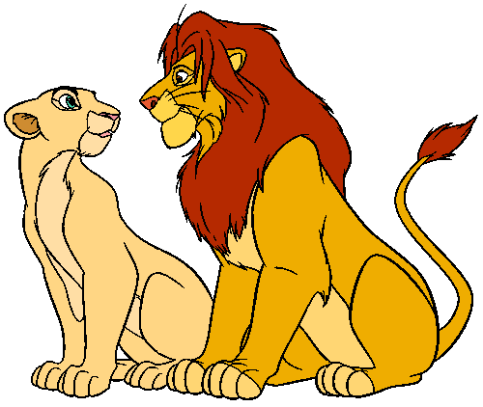 **APRIL— “ Lion King” Rehearsal Schedule** 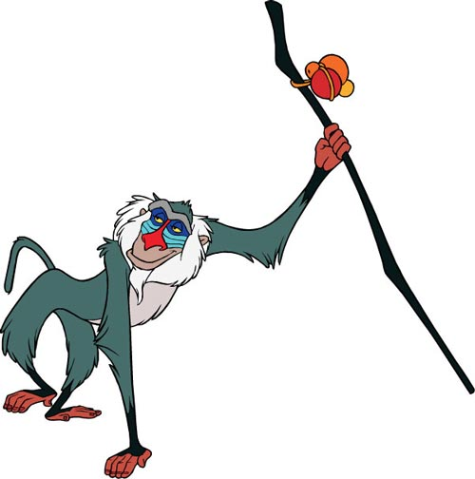

|  |  |  |  |  |  |  |
| --- | --- | --- | --- | --- | --- | --- |
| **Sunday** | **Monday** | **Tuesday** | **Wednesday** | **Thursday** | **Friday** | **Saturday** |
| 30 | 31 | 1 | 2 | 3 | 4 | 5 |
|  |  |  | **SPRING** | **BREAK** |  |  |
| 6 | 7 | 8 | 9 | 10 | 11 | 12 |
| **Costumes & Hair & Makeup**  **This Week** | **Run Scenes 1-7: 3:40-6:15 p.m.:** Required for Everyone | **Run Scenes 1-7: 3:40-6:15 p.m.:** Required for Everyone | **Run Scenes 8-13: 3:40-6:15 p.m.:** Required for Everyone | **Run Scenes 8-13: 3:40-6:15 p.m.:** Required for Everyone | **Run Entire Show: 1:00-5:30 p.m.:** Required for Everyone | **Run Entire Show/Polish: 9:00 a.m.-4:00 p.m.:** Required for Everyone |
| 13 | 14 | 15 | 16 | 17 | 18 | 19 |
| **Costumes & Hair & Makeup**  **This Week** | **Run Entire Show: 3:40-7:15 p.m.:** Required for Everyone | **Final Dress Rehearsal: 3:40-8:00 p.m.:** Required for Everyone | **Final Polishing: 3:40-5:30 p.m.:** Required for Everyone | **Afternoon Performance for Oakcrest**  **at 1:30 p.m.**  CALL TIME in gym 12:30 p.m.  4th graders will eat lunch at 12:00 p.m.  **Cast Pictures:3:40-5:30pm** | **Morning Performance for Oakcrest at 9:15 a.m.**  CALL TIME in gym 8:00  **Evening Performance**  **at 6:30 p.m.**  CALL TIME in gym 5:15 p.m. | **Performance at 6:30 p.m.**  CALL TIME in gym 5:15 p.m. |
| 20 | 21 | 22 | 23 | 24 | 25 | 26 |
|  | **Performance at 6:30 p.m.**  CALL TIME in gym 5:15 p.m. | **FINAL Performance**  **at 6:30 p.m.**  CALL TIME in gym 5:15 p.m |  |  | **CAST PARTY**  **&**  **COSTUME RETURNS**  **1:00 TO 4:00 pm** |  |